**ARRAYS AND**

**STRUCTURES**

**LAB # 12**



**Spring 2019**

**CSE102L Computer Programming Lab**

Submitted by: **SHAH RAZA**

Registration No. : **18PWCSE1658**

Class Section: **B**

“On my honor, as student of University of Engineering and Technology, I have neither given nor received unauthorized assistance on this academic work.”

Student Signature: ______________

Submitted to:

**Engr. Madiha Sher**

June 21, 2019

Department of Computer Systems Engineering

University of Engineering and Technology, Peshawar

## Objectives:

To practice arrays and structures

**TASK #1:**

Write a program to cyclically rotate an array by N. Take N as input from user. Give the user choice of selecting rotate left or rotate right.

**Code:**

#include <iostream>

using namespace std;

const int SIZE=6;

void Input(int *A)

{

for (int i=0;i<SIZE;i++)

cin>>*(A+i);

}

void Rotate(int *A,char ch,int N)

{

if (ch=='L'||ch=='l')

{

for(int i=0;i<N;i++)

{

int temp=*A;

for(int a=0;a<SIZE-1;a++)

{

*(A+a)=*(A+a+1);

}

*(A+SIZE-1)=temp;

}

}

else if (ch=='R'||ch=='r')

{

for(int i=0;i<N;i++)

{

int temp=*(A+SIZE-1);

for(int a=SIZE-1;a>0;a--)

{

*(A+a)=*(A+a-1);

}

*A=temp;

}

}

else

cout<<"Please respond with only L or R \n";

}

void display(int *A)

{

for (int i=0;i<SIZE;i++)

cout<<*(A+i);

}

int main()

{

char ch;

int N,arr[SIZE];

cout<<"Please Enter L/l to rotate left or R/r to rotate right: ";

cin>>ch;

cout<<"Please Enter the number of times you want to rotate:";

cin>>N;

cout<<"Enter the Array: \n";

Input(arr);

Rotate(arr,ch,N);

cout<<"After rotation: ";

display(arr);

return 0;

}

**Output (Compilation, testing and debugging):**

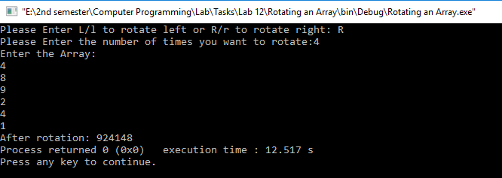

**TASK #2:**

Write a program that takes a string as an input and displays the frequency of all the alphabets.

**Code:**

#include <iostream>

#include <stdio.h>

using namespace std;

const int SIZE=100;

void input(char* A)

{

gets(A);

}

void frequency(char *A)

{

for(int i=65;i<=90;i++)

{

int counter=0;

for (int a=0;A[a]!='\0';a++)

{

if (A[a]==i||A[a]==i+32)

counter++;

}

cout<< (char) i <<" : "<<counter<<endl;

}

}

int main()

{

char arr[SIZE];

cout <<"Enter a string: \n";

input(arr);

cout<<"Frequency of Alphabets: \n";

frequency(arr);

return 0;

}

**Output (Compilation, testing and debugging):**

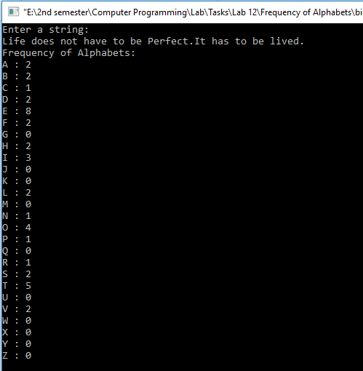

**TASK #3:**

Given an array arr that has numbers appearing twice or once. Write a program to identify numbers that occurred only once in the array.

**Code:**

#include <iostream>

using namespace std;

const int SIZE=5;

void input (int *A)

{

for (int i=0;i<SIZE;i++)

cin>>*(A+i);

}

void repitition(int A[])

{

for (int i=0;i<SIZE;i++)

{

int counter=0;

for(int a=0;a<SIZE;a++)

{

if(A[i]==A[a])

counter++;

}

if(counter==1)

cout<<A[i]<<endl;

}

}

int main()

{

int arr[SIZE];

cout<<"Enter the Array: \n";

input(arr);

cout<<"Numbers that appear only one time in Array: \n";

repitition(arr);

return 0;

}

**Output (Compilation, testing and debugging):**

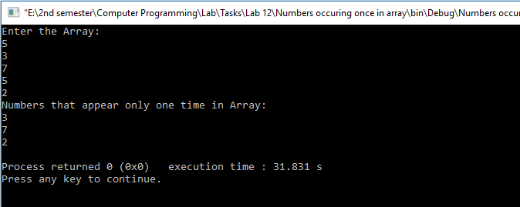

**TASK #4:**

Write a program to develop student information system. This system should be able to take the student’s credentials, like name, reg no and semester no, as input and store them in a structure variable Student_t. Print the data of students in ascending order of their registration numbers.

**Code:**

#include <iostream>

#include <stdio.h>

#include <string>

using namespace std;

const int SIZE=5;

struct student

{

int reg;

char name[30];

int semester;

}Student_t[SIZE];

int strlen(char *A) //strlen Function Definition

{

int i=0;

for(;A[i]!='\0';i++);

return i;

}

void input(student *s)

{

cout<<"Reg no: ";

cin>>s->reg;

cout<<"Name: ";

cin>>s->name;

cout<<"Semester: ";

cin>>s->semester;

}

void display()

{

int counter=0;

for (int n=0;;n++)

{

for(int i=0;i<SIZE;i++)

{

if(Student_t[i].reg==n)

{

cout<<"Reg No.: "<<Student_t[i].reg<<endl;

cout<<"Name: "<<Student_t[i].name<<endl;

cout<<"Semester: "<<Student_t[i].semester<<endl;

counter++;

break;

}

}

if(counter==SIZE)

break;

}

}

int main()

{

for(int i=0;i<SIZE;i++)

{

cout<<"Input the Information of student "<<i+1<<endl;

input(&Student_t[i]);

}

cout<<"Students Information in ascending order of registration number: \n";

display();

return 0;

}

**Output (Compilation, testing and debugging):**

